**Lab #6**

2.

Firstly, since the Area is given as a function in terms of radius and height, it is important to replace the height variable with one that is also in terms of radius. This is so that the entire Area function can be written in terms of radius and the derivative could then be calculated. To rewrite height in terms of radius, we can rearrange and rewrite the volume equation with the given volume of .

We can use this equation for height and replace h in the equation for surface area.

We can use this area equation to find the optimal radius to make the can with the least surface area. This can be done by plotting the graph and finding its derivative as well. We can then analyse the roots of the derivative as it would represent when the surface area graph is at a minimum. To do this, we can use the following code:

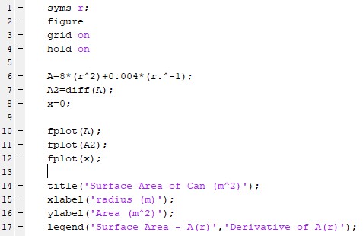

The purpose of the x=0 line is to find around where the derivative function crosses the x-axis. This value would be the root of the function and the radius that would result in the minimum surface area. This step is not necessary as with MatLab, it is possible to hover a cursor over points in a graph to find roots, but for the sake of visual aid, I included this line to see the crossing of the x-axis.

The code above results in the following graph:

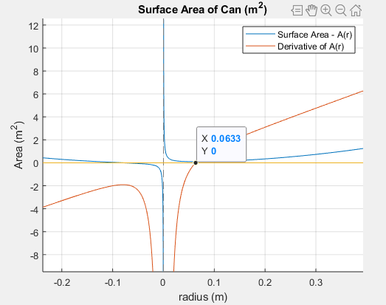

The graph shows that the Derivative function has a root of 0.0633 which means a radius of 0.0633m would result in the minimum surface area for the can. Now that we have the optimal radius, we can use the height equation in terms of radius to calculate the height of the can that would correspond to this radius. It is also important to note the negative root is not taken because a negative radius does not exist.

This means that for the can to be made up of the least amount of material, the radius of the can must be about 0.0633m and the height would be about 0.1589m.

When an engineer is faced with a problem like this, it is important for the engineer to understand clearly what is being asked for and the process to follow to find the solution. In the case of optimization such as this problem, it would be important to rewrite equations so that they are in terms of one variable so that the derivatives can be calculated. It would also be important for the engineer to recognize that the roots of the derivative symbolize where the original function is at a maximum or a minimum. With knowledge as well as the information in the question, the engineer should be able to solve the problem easily especially with the aid of MatLab that makes it visually easier to comprehend and analyse.